*Florida International University*

*School of Computing and Information Sciences*

Software Engineering Focus

Feature Document

User Story #208

# Add blog post

**Name:** Nathally Perez

**Team Member(s):** Mariana Sebastian

**Project:** Swifast Website 1.0

**Product Owner(s)**: Kianoosh G. Boroojeni

**Mentor(s)**: Mohsen Taheri

**Instructor**: Masoud Sadjadi

**User Story Name: Add blog post**

1. Description: As an admin, I want to be able to add new post to the blog, so that I can inform the users with new stories about driverless car.

Acceptance Criteria

* Admin should be provided with add post button that contains the title, content and image url input fields.
* Admin should be provided with the login form with appropriate input fields labeled.
* User must be existed in the database.
* An error message should display as when the user enters the invalid data.

**Use Case #208**

Name: Add blog post

Actor: Admin of the website

Preconditions: Connected to <http://localhost:4000>

Description <Flow of events>:

1. Click blog menu on the navigation bar.
2. Click add new blog post button on the page.
3. Enter login information and click login
4. Enter title, content and image url and click on create post
5. Redirected to blog page

**Use Case Diagram**

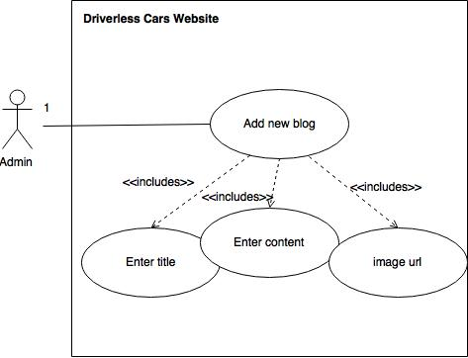

**Sequence Diagram:**

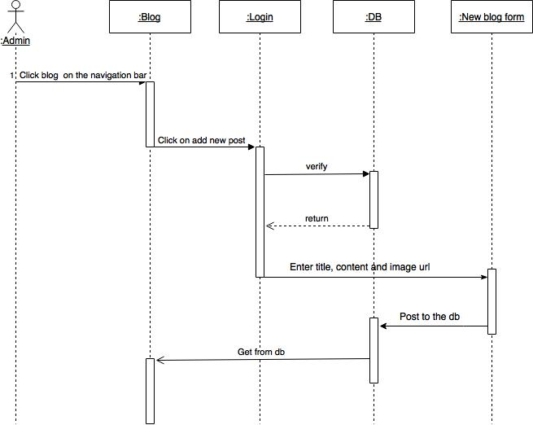

**Class Diagram:**

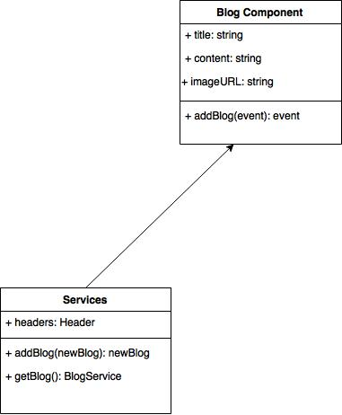

**Unit Test**

**Test case 1(Sunny Day)**

* Test case ID: DCW-208-01
* Description/Summary of Test: Ensure that the articles are being posted successfully.
* Pre-condition:

1. The server is running on the localhost port 4000
2. Admin click blog menu tab.
3. Admin click add new post button
4. Admin enters:
   1. Username: admin
   2. Password: 1234
5. Admin enters:
   1. Title
   2. Content
   3. Image

* Expected Results: Admin is able to post an article to the database and the blog page successfully
* Actual Result: Admin was able to post articles to the blog page successfully.
* Status (Fail/Pass): PASSED

**Test case 2(Rainy Day)**

* Test case ID: DCW-208-02
* Description/Summary of Test: Admin leaves a field empty
* Pre-condition: The server is running on the localhost port 4000

1. Admin click blog menu tab.
2. Admin click add new post button
3. Admin enters:
   1. Username: admin
   2. Password: 1234
4. Admin enters:
   1. Title
   2. Image

* Expected Results: Visitor is unable to post an article to the blog page and database successfully.
* Actual Result: Admin was not able to successfully post an article to the blog page and the database.
* Status (Fail/Pass): PASSED

**Integration Test**

The integration test was made using postman and I tested posting the blog articles to the blog page, the database and I did not have bugs and they were functioning correctly. The result were positive.

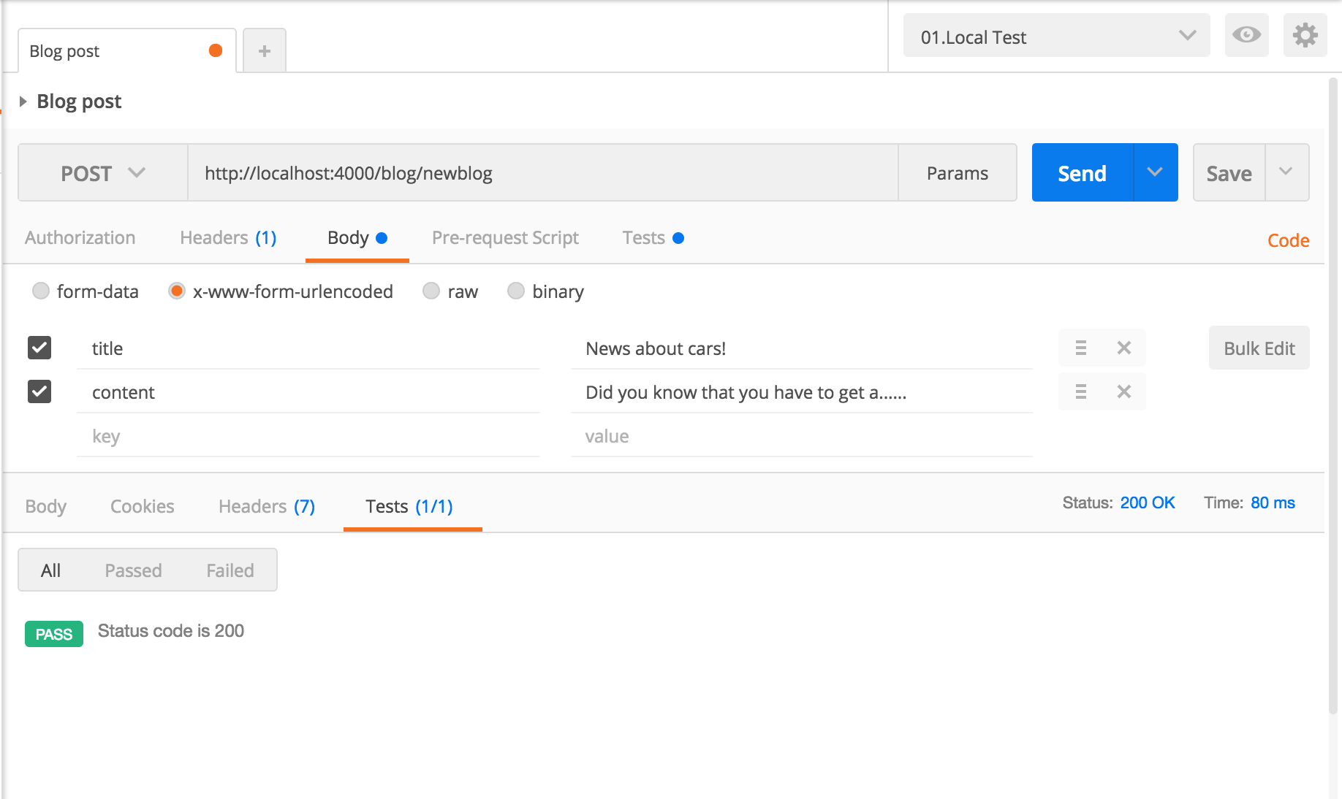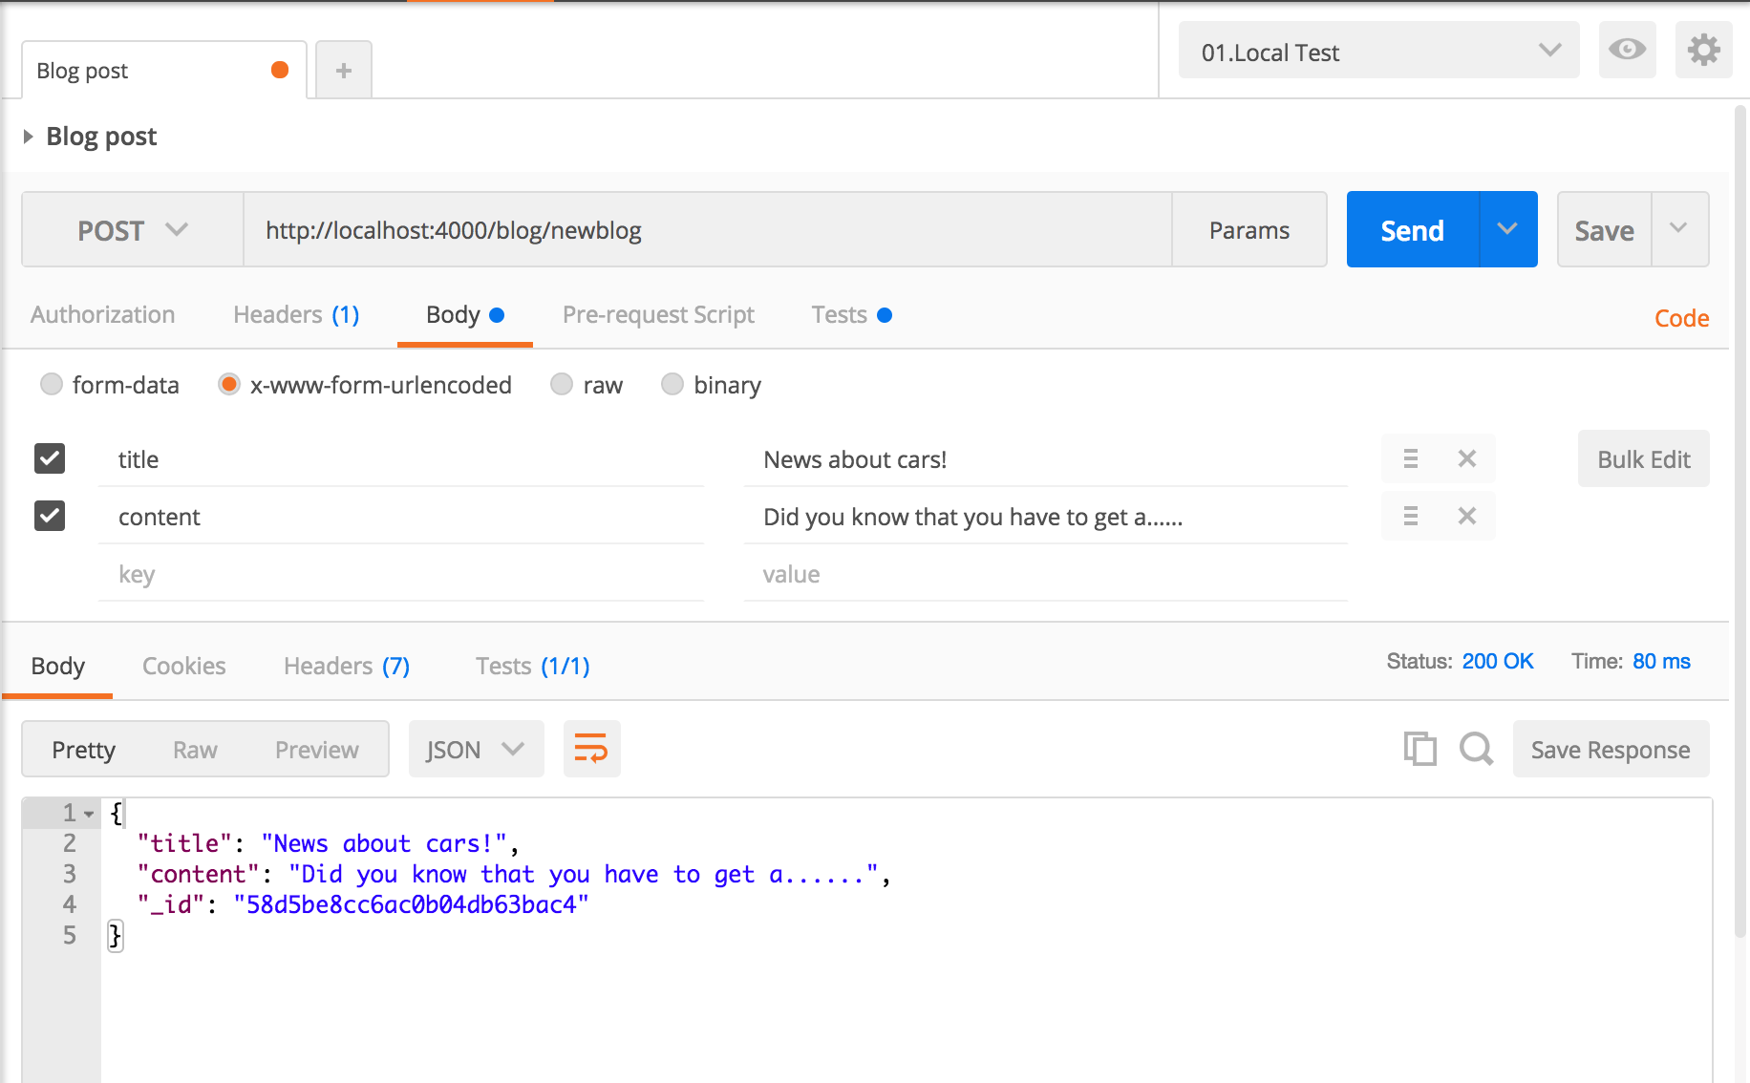

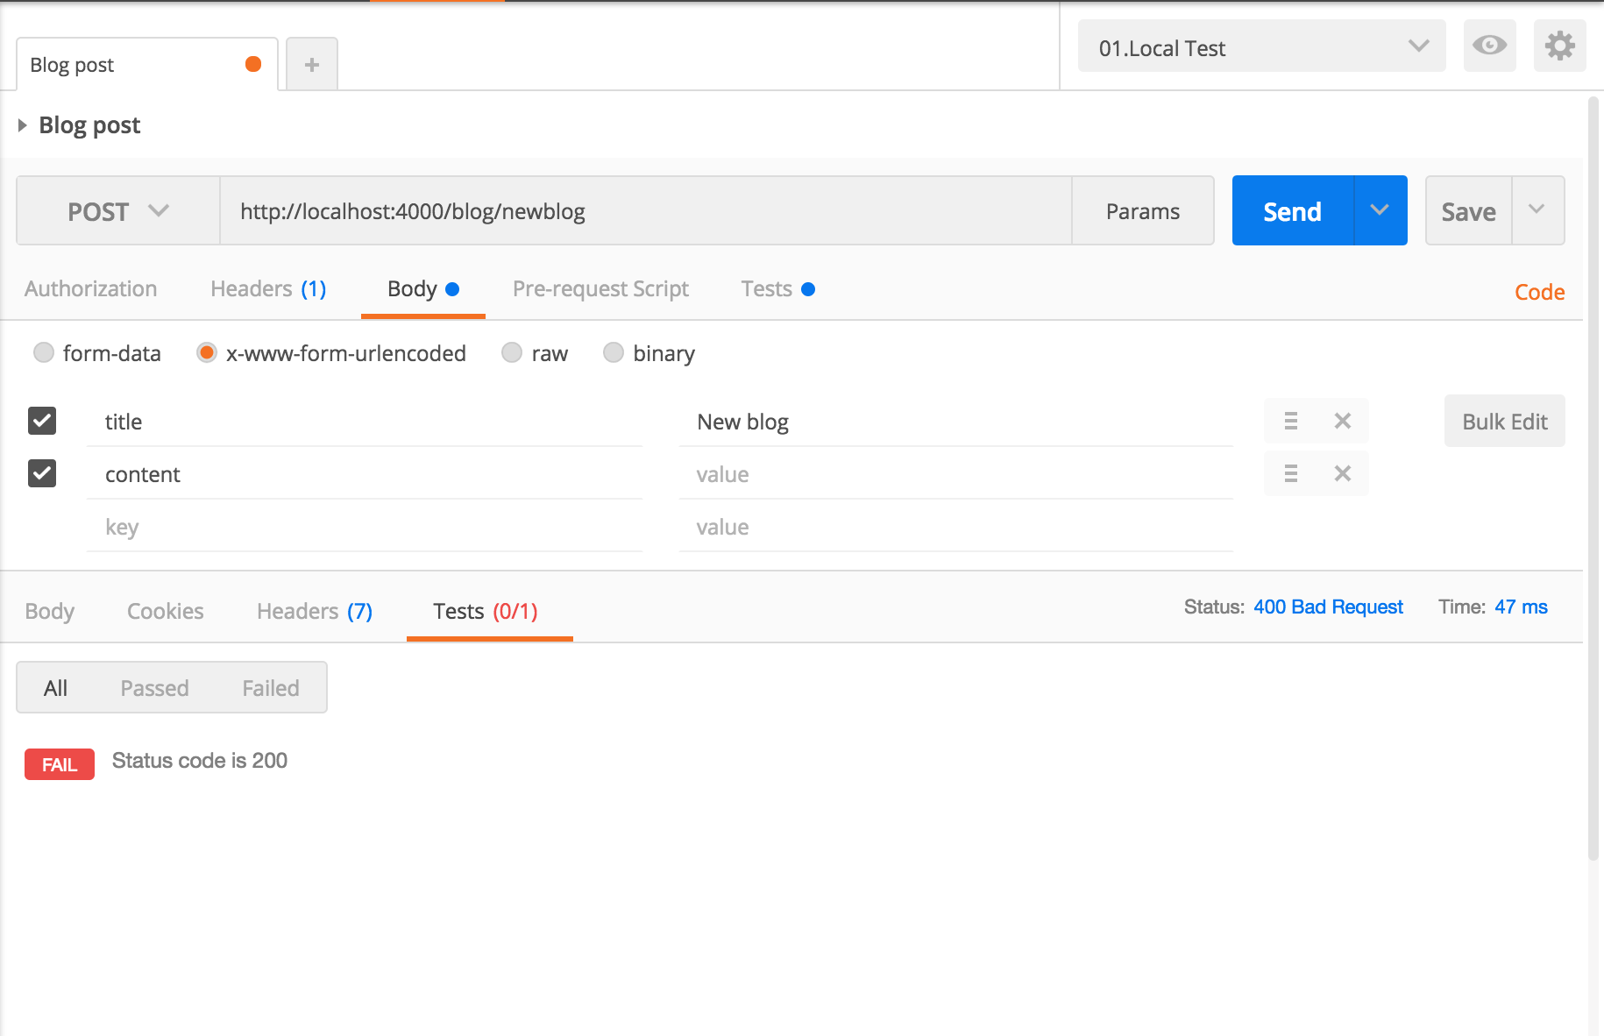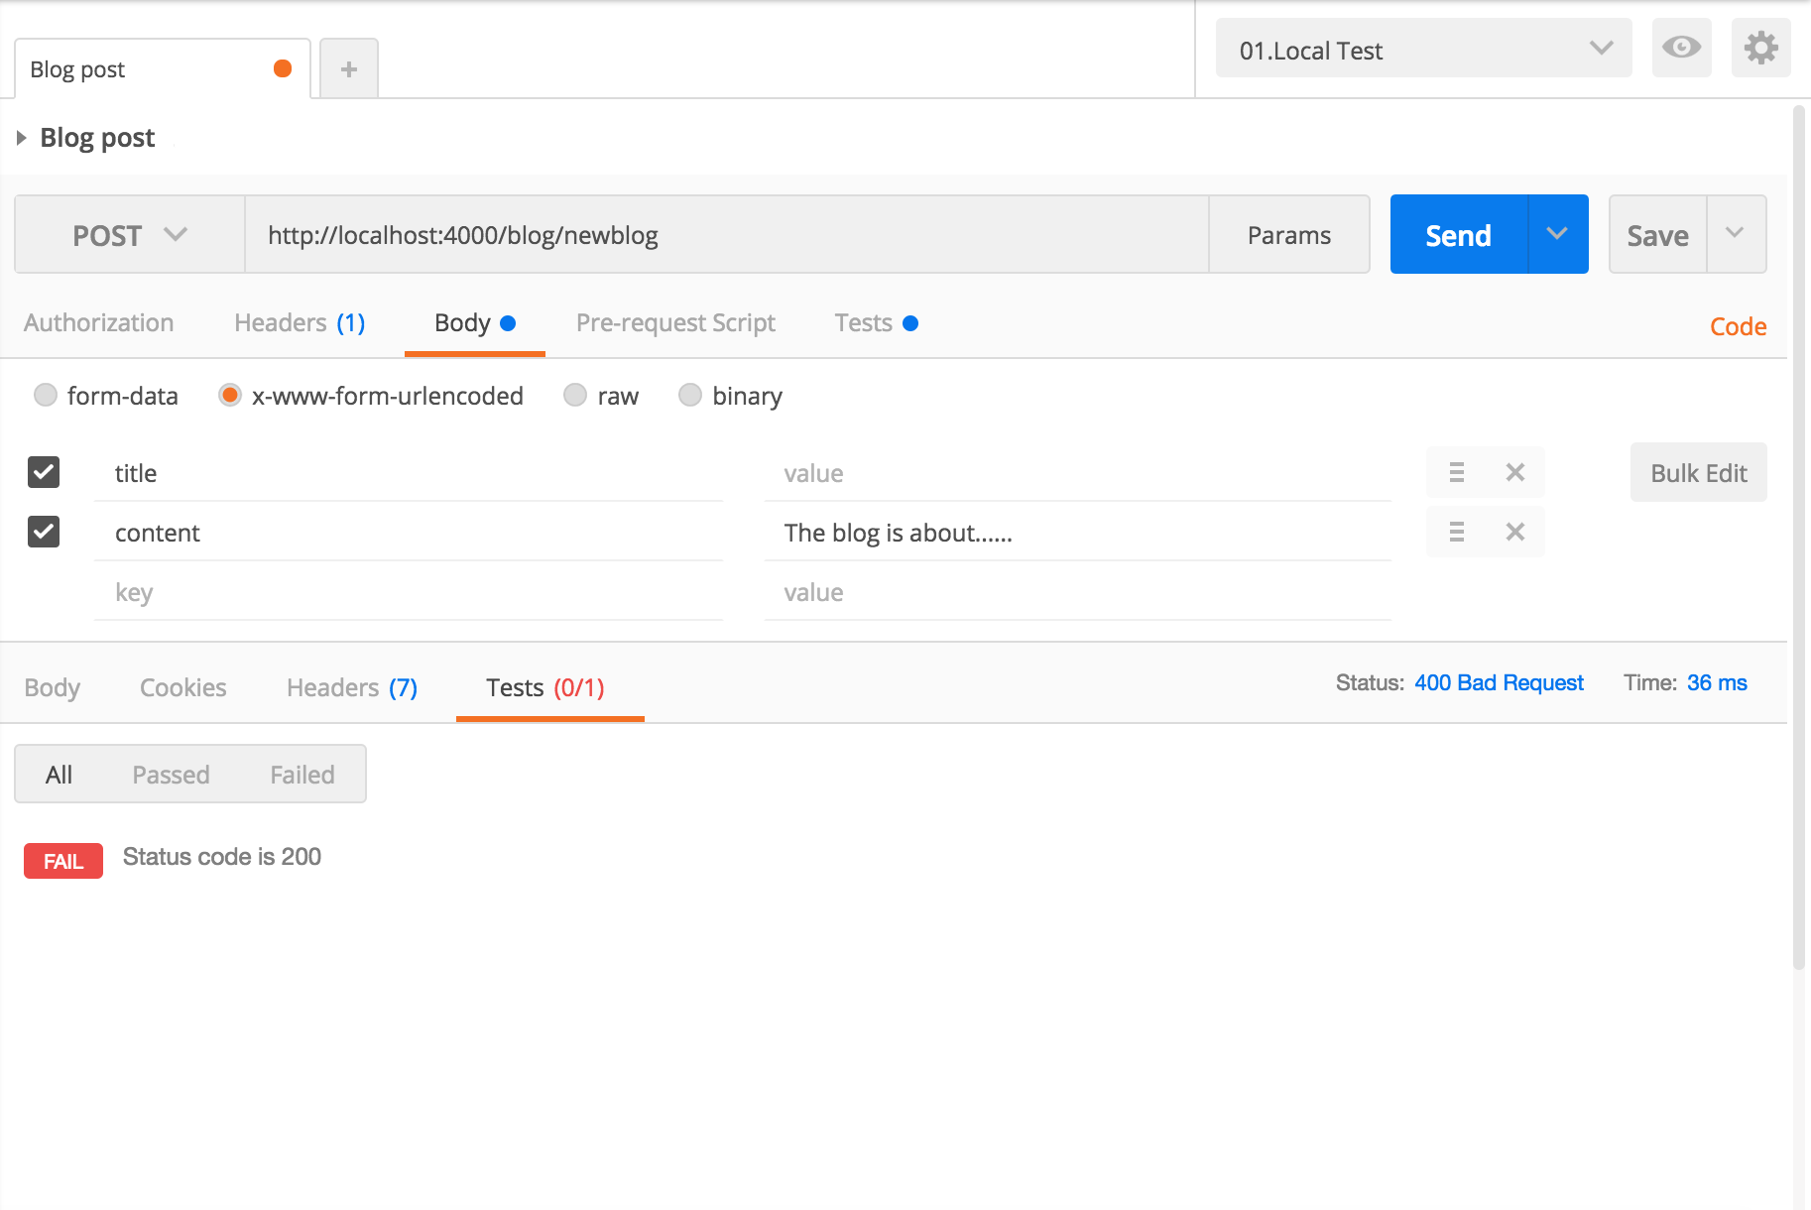

**Visual User Guide** :

